Course 6 end-of-course portfolio project overview: Automatidata

# Learn about the Course 6 Automatidata workplace scenario!

The end-of-course project in Course 6 focuses on your ability to build a machine learning model for a project. As a reminder, in Course 1 you developed a project proposal that outlined milestones, which progress with each of the end-of-course projects. A visual representation is provided in the graphic shown here:

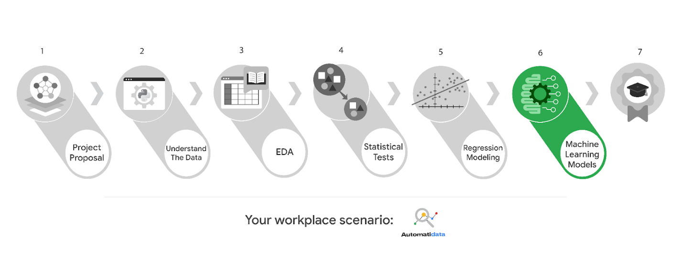

Learn more about the project, your role, and expectations in this reading.

# Background on the Automatidata scenario

Automatidata works with its clients to transform their unused and stored data into useful solutions, such as performance dashboards, customer-facing tools, strategic business insights, and more. They specialize in identifying a client’s business needs and utilizing their data to meet those business needs.

Automatidata is consulting for the New York City Taxi and Limousine Commission (TLC). New York City TLC is an agency responsible for licensing and regulating New York City's taxi cabs and for-hire vehicles. The agency has partnered with Automatidata to develop a regression model that helps estimate taxi fares before the ride, based on data that TLC has gathered.

The TLC data comes from over 200,000 taxi and limousine licensees, making approximately one million combined trips per day.

***Note:*** *This project's dataset was created for pedagogical purposes and may not be indicative of New York City taxi cab riders' behavior.*

## Project background

Automatidata is ready to create a machine learning model for TLC. The following tasks are needed to complete the project:

* Model building
* Model evaluation
* Summarize findings for Automatidata and the stakeholders at TLC

## Your assignment

You will create a machine learning model for the TLC data. You will be responsible for leading these tasks, which include feature engineering, model development, and evaluation.

# Team members of Automatidata and the New York City TLC

## Automatidata Team Members

* Udo Bankole, Director of Data Analysis
* Deshawn Washington, Data Analysis Manager
* Luana Rodriquez, Senior Data Analyst
* Uli King, Senior Project Manager

Your teammates at Automatidata have technical experience with data analysis and data science. However, you should always be sure to keep summaries and messages to these team members concise and to the point.

## New York City TLC Team Members

* Juliana Soto, Finance and Administration Department Head
* Titus Nelson, Operations Manager

***Note:*** *The story, all names, characters, and incidents portrayed in this project are fictitious. No identification with actual persons (living or deceased) is intended or should be inferred. And, the data shared in this project has been created for pedagogical purposes.*

The TLC team members are program managers who oversee operations at the organization. Their roles are not highly technical, so be sure to adjust your language and explanation accordingly.

# Specific project deliverables

In this end-of-course project, you will gain valuable practice of your new skills as you complete the following deliverables:

* Complete a PACE planner mapping questions, details, and action items for each stage of the project scenario
* Answer the questions in the Jupyter notebook project file
* Design and implement a machine learning model
* Draft an executive summary of your results

Good luck in your new role! Automatidata looks forward to seeing how you communicate your creative work and approach problem-solving!

# Key takeaways

The end-of-course project is designed for you to practice and apply course skills in a fictional workplace scenario. By completing each course’s end-of-course project, you will have work examples that will enhance your portfolio and showcase your skills for future employers.

Mark as completed

Like

Dislike

Report an issue